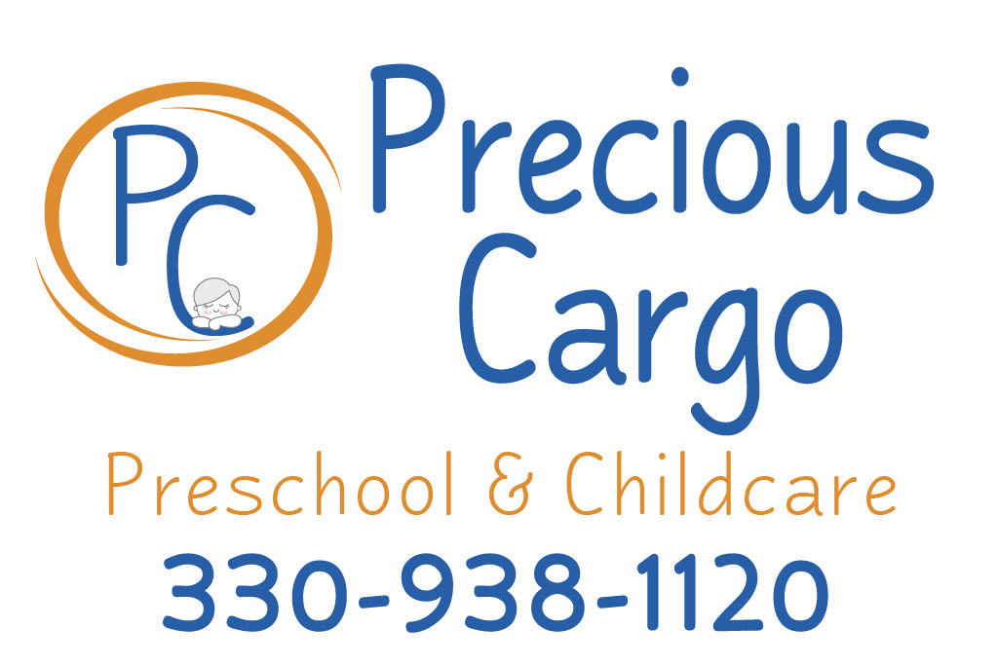

**Preschool Supply List**

Please be sure that your child has the following items onsite every day they are attending.

* Water bottle (for water only) labeled with child name. *these must go home every day to be washed.
* Pull-ups if potty training.
* At least 1 full set of extra clothing.
* Small blanket for naptime.
* Weather appropriate clothing for outdoor play for the current season.

**PARENT RESOURCES**

Jobs & Family Services

449 S Meridian St. Ravenna, OH 44266 (330)297-3750

Food Pantries

Center of Hope

1081 W Main St. Ravenna, OH 44266 (330)297-5454

Alliance Community Pantry

215 E Market St. Alliance, OH 44601 (330)680-8130

Libraries

Reed Memorial

167 E Main St. Ravenna, OH 44266 (330)296-2827

Mahoning Public

305 Wick Ave. Youngstown, OH 44503 (330)744-8636

Salvation Army

1501 Glenwood Ave. Youngstown, OH 44511